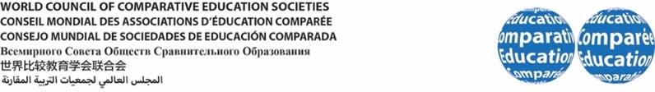

2nd WCCES Symposium

Immigrants and Comparative Education: Call to Re/Engagement
UNESCO International Bureau of Education (IBE), Geneva, Switzerland
14-15 January 2019
November 17 2018
Dear ……………………………………

We are pleased to inform you that you are cordially invited to participate in the 2nd WCCES Symposium to be held on January 14-15, 2019 at the UNESCO International Bureau of Education in Geneva (Switzerland). You are kindly requested to apply for Schengen Visa (if required). We look forward to having you with us in Geneva for fruitful deliberations with academics and practitioners, networking with colleagues from all over the world, and a wonderful time together in the scenic environs of UNESCO IBE.

Thanking You,

Yours Sincerely,
Professor N’Dri T. Assié-Lumumba Dr. Mmantsetsa Marope
Cornell University, USA Symposium Co-Convener
WCCES President Director, UNESCO IBE

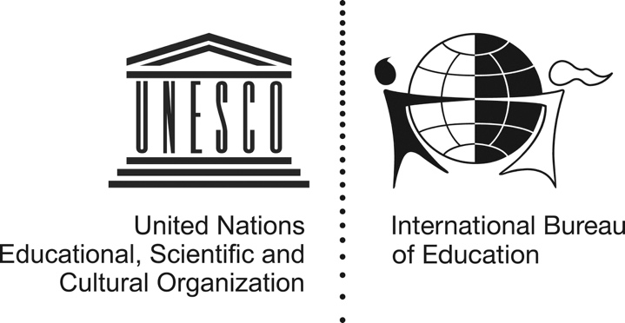
15 route des Morillons, 1218 Le Grand-Saconnex, Geneva, Switzerland
Contact: Dr. Simona Popa Tel: +41 22 555 06 00 Email: s.popa@unesco.org

